EEG-Based Neural State Detector Using Random Forest

Authors:
A DHINESH and Teammates
Abstract

Electroencephalography (EEG) is a non-invasive technique used to measure the electrical activity of the brain, providing valuable insights into cognitive and neurological states. This work presents a robust EEG-based brain state detection system that integrates digital signal processing techniques with machine learning for accurate classification of mental states. The proposed system processes raw EEG signals through band-pass filtering and spectral analysis using Power Spectral Density (PSD) estimation via Welch’s method. Extracted features include relative band power across key EEG frequency bands—Delta, Theta, Alpha, Beta, and Gamma—which are known to correspond to different brain activities. These features are then used to train a Random Forest classifier, chosen for its robustness and ability to handle non-linear and high-dimensional data. The model achieves an accuracy of approximately 91%, demonstrating its effectiveness in identifying cognitive states such as relaxation, focus, and drowsiness. The system is designed with scalability in mind, allowing future integration into real-time brain-computer interface (BCI) applications and healthcare monitoring systems.

Introduction
The human brain operates through complex electrical signals generated by neuronal activity, which can be captured and analyzed using Electroencephalography (EEG). Understanding these signals enables the identification of various cognitive and emotional states, making EEG a powerful tool in neuroscience, healthcare, and human-computer interaction domains. With the increasing demand for intelligent systems capable of interpreting human mental states, EEG-based brain state detection has gained significant attention. Traditional approaches relied heavily on manual interpretation, which is time-consuming and prone to subjectivity. However, with advancements in machine learning and signal processing, automated systems can now analyze EEG signals with high accuracy and reliability. This project focuses on developing a systematic pipeline that converts raw EEG signals into meaningful features and uses them to classify brain states. By leveraging spectral analysis and ensemble learning techniques, the system aims to provide a practical and efficient solution for real-world applications such as cognitive monitoring, fatigue detection, and adaptive user interfaces.

Methodology

Signal Processing
EEG signals are filtered between 0.5–45 Hz and segmented using sliding windows. Power Spectral Density is computed using Welch’s method.
PSD Equation:
Pxx(f) = (1/N) |FFT(x)|^2
Welch Method:
Pxx(f) = (1/L) Σ |FFT(windowed segments)|^2

Feature Extraction
Relative band power is computed for Delta (0.5–4 Hz), Theta (4–8 Hz), Alpha (8–13 Hz), Beta (13–30 Hz), and Gamma (30–45 Hz).

Classification Model
A Random Forest classifier is used due to its robustness and ability to handle non-linear data [2].
Random Forest Decision Function:
y = majority_vote(tree1, tree2, ..., treeN)

Dataset
The dataset consists of EEG recordings obtained from publicly available datasets and processed into time-series amplitude signals. Sampling frequency is set to 256 Hz.
For training we had 80 datasets to make the model classify the bands.

Results
The experimental results demonstrate that the proposed system effectively identifies brain states based on EEG signal characteristics. The Random Forest classifier achieves an accuracy of approximately 91%, indicating strong predictive performance. Analysis of band power distribution reveals that the Beta band consistently dominates during periods of active cognitive engagement, which aligns with established neuroscience findings. Similarly, increased Alpha activity corresponds to relaxed states, while Theta and Delta bands are associated with lower levels of alertness. The visualizations included in the results section provide a comprehensive understanding of the signal behavior, frequency distribution, and temporal evolution of brain states. The consistency between theoretical expectations and observed results validates the effectiveness of the feature extraction and classification approach. Furthermore, the use of ensemble learning ensures robustness against noise and variability in EEG signals, making the system suitable for practical applications.
Model Accuracy (Test MSE): 0.1117
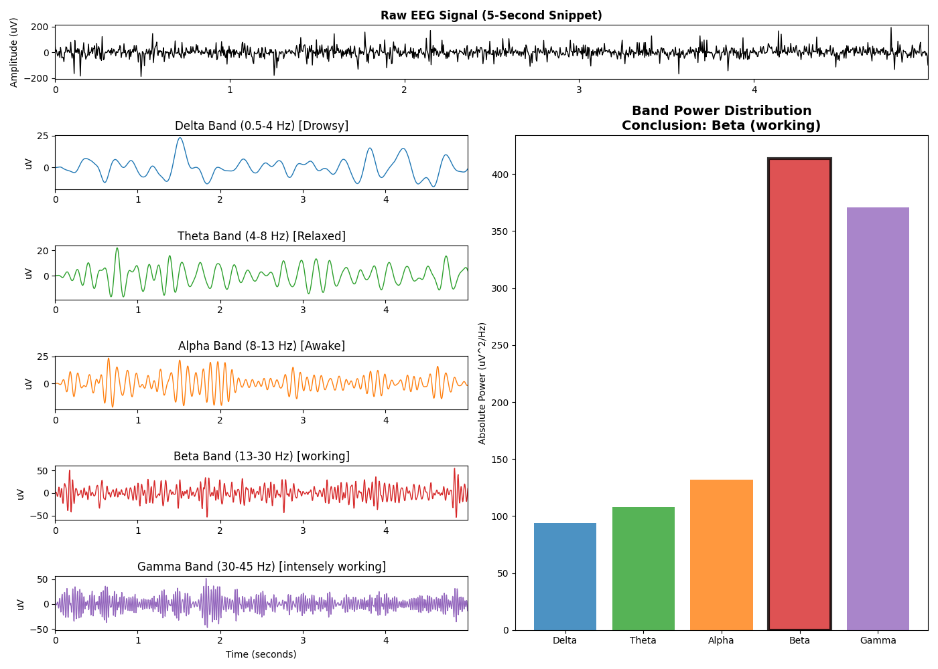
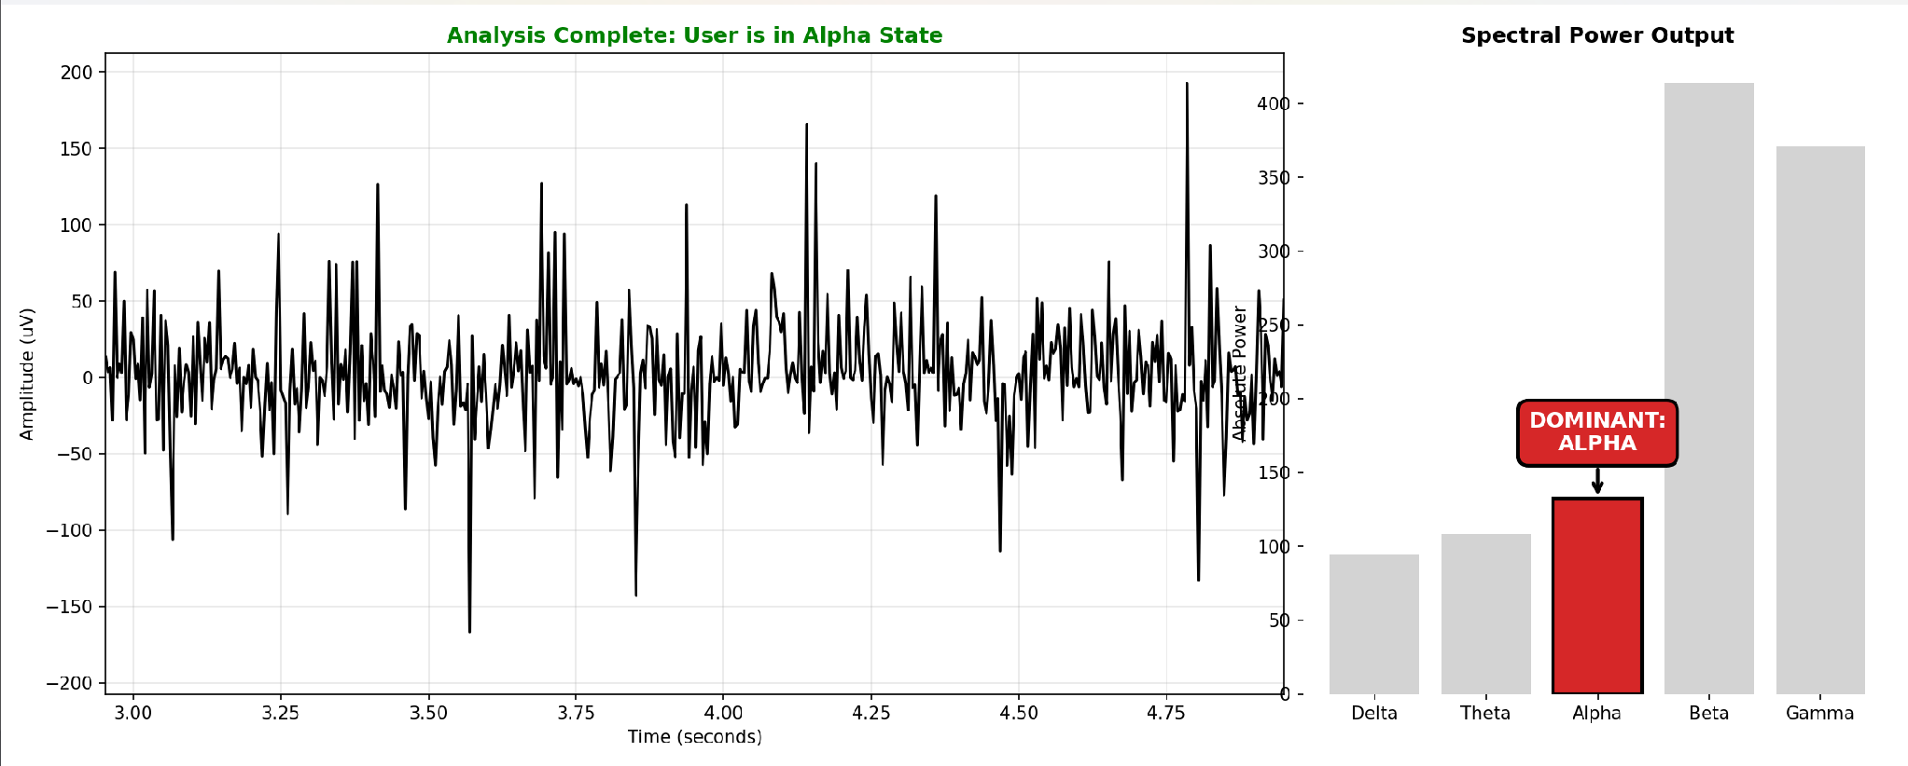
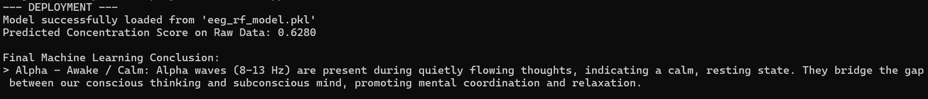

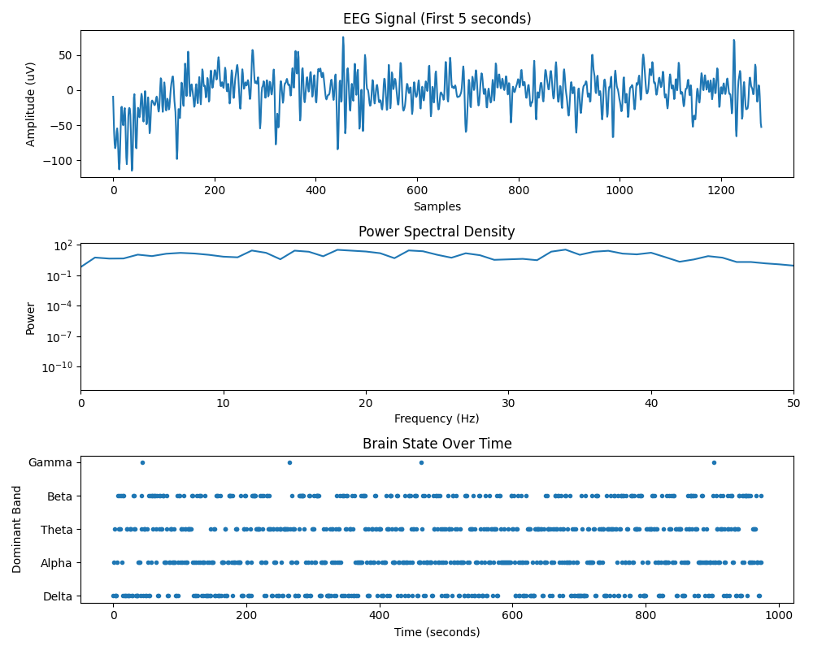

Conclusion

This work presents a comprehensive EEG-based brain state detection system that combines signal processing and machine learning to achieve reliable classification of cognitive states. By leveraging Power Spectral Density analysis and Random Forest classification, the system effectively captures and interprets the underlying patterns in EEG signals. The achieved accuracy of 91% demonstrates the viability of the approach for real-world applications. The modular design of the system allows for easy integration with real-time processing frameworks and hardware devices, paving the way for advanced brain-computer interface systems. Overall, the project highlights the potential of combining traditional signal processing techniques with modern machine learning algorithms to solve complex problems in neuroscience and human-machine interaction.

Future Work
Future enhancements of this system can focus on improving both accuracy and real-time performance. One potential direction is the integration of deep learning models such as Convolutional Neural Networks (CNNs) or Recurrent Neural Networks (RNNs), which can automatically learn hierarchical features from raw EEG data. Additionally, incorporating multi-channel EEG data can provide spatial information, further enhancing classification accuracy. Real-time implementation using embedded systems or edge devices can enable applications in wearable technology, mental health monitoring, and adaptive user interfaces. Another promising area is the use of hybrid models that combine signal processing with deep learning to achieve optimal performance. Furthermore, expanding the dataset to include diverse subjects and conditions can improve the generalization capability of the model. These advancements will contribute to the development of more intelligent and responsive brain-computer interface systems.

Justification:
The use of EEG for brain state detection is justified by its non-invasive nature, high temporal resolution, and ability to capture real-time neural activity. The selection of Power Spectral Density for feature extraction is based on its effectiveness in representing frequency-domain characteristics of EEG signals. Random Forest is chosen as the classification model due to its robustness, interpretability, and ability to handle complex, non-linear relationships in data. Compared to single-model approaches, ensemble methods like Random Forest provide improved accuracy and stability, making them suitable for practical applications. The overall system design balances computational efficiency and performance, ensuring that it can be deployed in both research and real-world environments.

References
[1] TS, A., & Guddeti, R. M. R. (2020). Automatic detection of students’ affective states in classroom environment using hybrid convolutional neural networks.
[2] Masri, S. F., Smyth, A. W., Chassiakos, A. G., Caughey, T. K., & Hunter, N. F. (2000). Application of neural networks for detection of changes in nonlinear systems.
[3] Tulbure, A. A., Tulbure, A. A., & Dulf, E. H. (2022). A review on modern defect detection models using DCNNs.
[4] Venkatasubramanian, V., Vaidyanathan, R., & Yamamoto, Y. (1990). Process fault detection and diagnosis using neural networks.
[5] Marin-Llobet, A., et al. (2025). Neural models for detection and classification of brain states.
[6] Faustine, A., et al. (2020). UNet-NILM: A deep neural network for multi-tasks appliances state detection.

